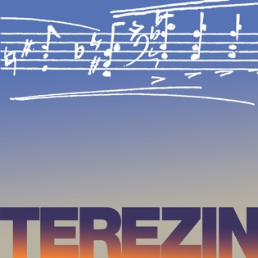
TEREZÍN MUSIC FOUNDATION
Mark Ludwig, Executive Director
www.terezinmusic.org

FOR IMMEDIATE RELEASE — MARCH 2020

Contact: Lisa Pemstein, P.R. Director
Phone: 857-222-8262
Email: lpemstein@terezinmusic.org
Website: www.terezinmusic.org
Photos: Furnished on request
Interviews: Available on request

BROOKLINE HIGH SCHOOL CAMERATA CHOIR AND ORCHESTRA MEMBERS TO PERFORM AND LEARN IN PRAGUE AND TEREZÍN, IN PROGRAMS DIRECTED BY TEREZÍN MUSIC FOUNDATION

PROGRAMS PRODUCED BY BROOKLINE RESIDENT MARK LUDWIG, TEREZÍN MUSIC FOUNDATION EXECUTIVE DIRECTOR AND FULBRIGHT SCHOLAR OF HOLOCAUST MUSIC

THREE PERFORMANCES: AT PRAGUE’S JERUSALEM SYNAGOGUE ON HOLOCAUST REMEMBRANCE DAY, APRIL 20; AT THE U.S. EMBASSY’S AMERICAN CENTER, PRAGUE, APRIL 23; AND AT TEREZÍN APRIL 22

CHOIR DIRECTED BY BHS DIRECTOR OF CHOIRS MICHAEL DRISCOLL

RABBI WILLIAM HAMILTON OF KEHILLATH ISRAEL IN BROOKLINE TO JOIN MARK LUDWIG IN OPENING YOM HASHOAH PROGRAM

APRIL 20 CONCERT PROGRAM INCLUDES CHORAL MUSIC BY NEWTON, MA COMPOSER DAVID L. POST

BROOKLINE —Brookline High School Camerata Choir will travel to Prague in the Czech Republic this April and perform three concerts produced by Terezín Music Foundation. Brookline resident Mark Ludwig, TMF Founder and Executive Director and a Fulbright Scholar of music under the Third Reich, was asked to produce concerts at the Jerusalem Synagogue on Yom Hashoah (Holocaust Remembrance Day) April 20, and at the U.S. Embassy’s American Center on April 23. He invited these outstanding young singers to take center stage, performing music composed by great artists imprisoned inside the Nazi concentration camp Terezín, alongside new works TMF commissioned to honor these legendary artists. In a third concert, as part of TMF’s ongoing international Holocaust education programs, the students will tour Terezín and perform in honor of those who made music there before them.

TMF is a local nonprofit dedicated to honoring the composers who miraculously created music in Terezín, a Nazi camp where 33,000 people died amidst grave suffering. As Mr. Ludwig says, “To hear this important and stirring music in Prague and Terezín, in the voices of these talented young artists, is moving indeed. I’m delighted to bring BHS students to these important venues, and to give them an experience which I hope they will always remember.”

Mr. Ludwig selected the repertoire for the Yom Hashoah concert, performed in the stunning and historic Jerusalem Synagogue. BHS Camerata Choir, directed by BHS Director of Choirs Michael Driscoll, will perform alongside one of Prague’s acclaimed choruses, Prague Conservatoire’s PUNKT. Following a memorial candle-lighting with Brookline’s Rabbi William Hamilton (of Kehillath Israel) and local Holocaust survivors, BHS Camerata Choir will sing “Wiegala, Wiegala,” a lullaby composed in Terezín by Ilse Weber. The program also presents TMF-commissioned works by Israeli, Irish, and American composers, including Newton, Massachusetts composer David L. Post. These contemporary pieces are settings of poetry by acclaimed American, Irish, Israeli, and Cuban poets; the poems are published in the TMF anthology Liberation (Beacon Press 2015, Mark Ludwig, Editor). The Yom Hashoah program closes with a second Terezín lullaby, this one by Gideon Klein, and the song “Oseh Shalom,” the Jewish prayer for peace. The concert is co-sponsored by The Jewish Community of Prague and Terezín Music Foundation.

The April 23 program at the U.S. Embassy’s American Center features music by Czech and American composers, including Gideon Klein and George Gershwin. Mr. Driscoll directs. The event, a joint program of the Embassy and TMF, celebrates Czech-American cultural exchange and is produced by Mr. Ludwig.

Another TMF commission by David L. Post is on the program at a fourth concert. BHS Orchestra members, under the direction of BHS Orchestra Conductor Nina Bishop, will perform his “Fantasia on a Virtual Chorale” Sunday, April 19 at Czech National Music Museum in Prague. The BHS students will also travel to Dresden, where they will continue to tour and perform.

GALLERY — Full-size photos available on request.
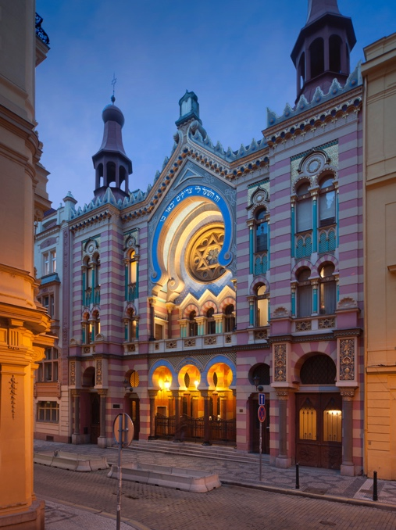

Jerusalem Synagogue, Prague
April 23 Yom Hashoah (Holocaust Remembrance Day) performance.

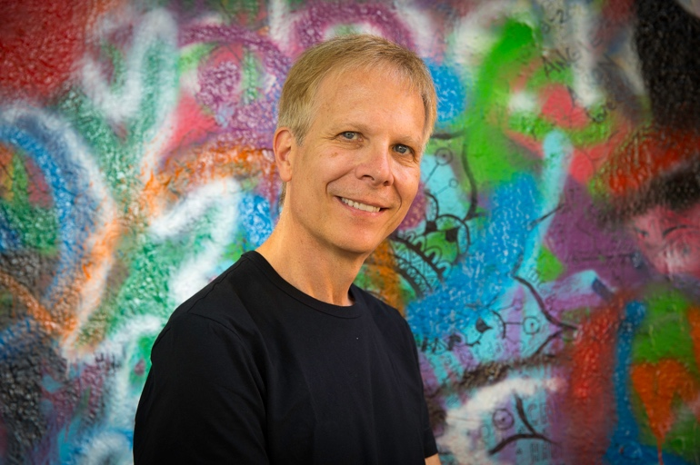
Mark Ludwig,
Terezín Music Foundation
Executive Director.
(photo by Michael J. Lutch
at “The Lennon Wall” in Prague)

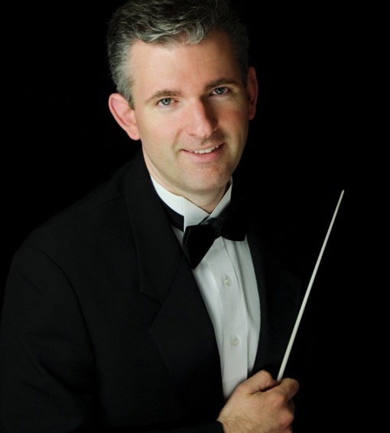

Michael Driscoll,
Brookline High School Director of Choirs.

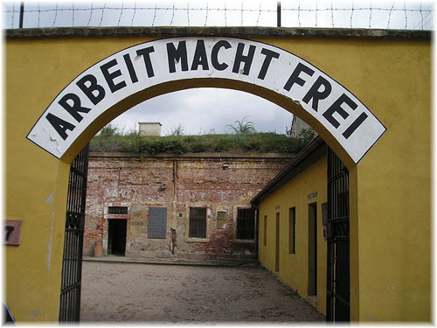

Entrance to Terezín Concentration Camp in the Czech Republic. “Arbeit Macht Frei” is the notoriously cruel Nazi lie meaning “Work makes one free.”

# # #

